Country Name  Country Outline  - GDP: 9.3 trillion euros / - GDP Per capita: 6801.6 euros  - Areas of marked S&T specialisations: /  Contact Information  - Name / Position: Mr Tony Wang / Project Head /  - Phone no. / e-mail: (+86) 13784766419 / 893887593@qq.com / | National Flag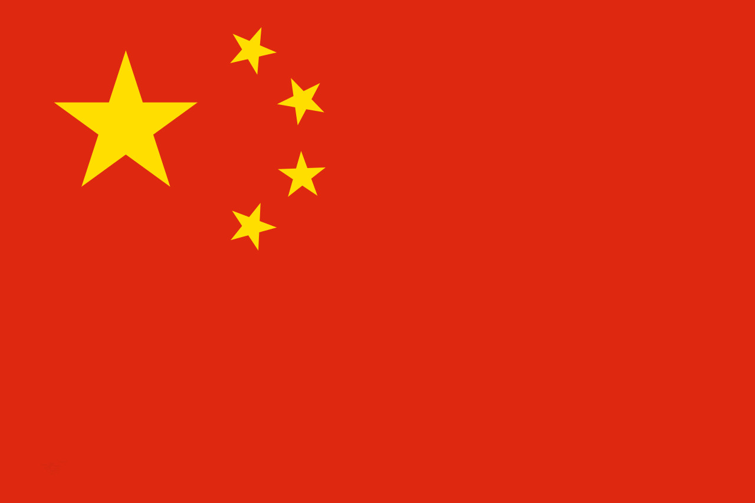

Introduction: Please provide a short introduction paragraph of your country by focusing on Science, Technology and Innovation.

1. Policies and Strategies in Science, Technology and Innovation
[Description] Please describe your STI Policies and strategies in detail. If needed, please provide some statistics (table, figures, etc.)

The overall orientation of Zhongjie Hi-tech Zone is “Bohai Wisdom Village, Aviation Green City”. Focusing on scientific innovation function in North Sector, and focusing on General Aviation Park, High-end Manufacturing Park and New Material&New Energy Park in South Area, it will develop into a national high-tech industrial zone, an innovation and technology city driven by general aviation industry, and an ecological demonstration sector for Sino-Euro cooperation.

2. National Programmes and Initiatives
[Description] If you have national programmes or initiatives targeting international cooperation including China, please describe it in detail so that more Chinese can have interests in these programmes.

* List of National Programmes open to the world Please fill out the table below.
Programme Title | Contents
Programme A  (website) | - Cooperation Type: Joint Research / Mobility / Individual Funding or…  - Funding Organisation:  - Call Opening/Closing Date:  - Participation Qualification:  - Project Duration:  - Funding Scale and Funding Scheme:  - Research Fields:  - Matching fund from Chinese government (if yes, what is funding process?)  - Others:
Programme B

3. Joint Activities with China in 2015
[Description] If you have joint programmes or event at the public level and private level, please describe it in detail.

Joint Committee meeting Target participants - representatives of implementing ministries, universities and academies of sciences

* List of Programmes of Activities with China in 2015 Please fill out the table below.
Programme Title | Contents
Activity A | - Activity (Programme) Outline: Date/Venue/etc.  - Major topic or agenda  - Target Participants  - Relevant Information:
Activity B
4. Others
[Description] If you have additional information to deliver, please describe it in detail.

[Description] In order to promote major MS organisations (Universities, Research Organisations, SMEs, etc.) to China, please fill out several major organisations as below:

* Key Research Organisations and Companies Please fill out the table below.
Organisation Name | Detailed information
Organisation 1  (website) | - Organisation type: University/Research Organisations/SME/( )  - Major Research Area/Product:  - Major Activities with China:  - Future Plans:  - Contact Information:  - Others:
Organisation 2
* The organisations/companies should be present in China or having active cooperation programmes with China.

