HUNGARY  Country Outline  - GDP: cca. 93.5 billion EUR(2013) GDP Per capita: cca. 10200 EUR (2013)  - Areas of marked S&T specialisations: automotive industry, pharma industry, ICT, biotechnology.  Contact Information  - Name / Position: Dr. Antal Nikodémus, Head of Department  Department for Science Diplomacy  Ministry of Foreign Affairs and Trade  - Phone no. / e-mail: + 36 1 458 2158 / Antal.Nikodemus@mfa.gov.hu | National Flag

Introduction:

In Hungary the Gross Domestic Expenditure on R&D (GERD) is increasing constantly. The GERD / GDP ratio in 2013 reached 1.41 per cent – the highest figure in the past two decades – but still below the 2.01 (2013) per cent average of the European Union.

Since 2008 there has been a positive trend as the proportion of R&D expenditure from the business sector has increased rapidly and now exceeds the public resources. In countries leading innovation in the European Union - also in the United States and Japan - companies fund the majority of investments related to research and development and innovation.

The performance of the EU national innovation systems is measured by the Summary Innovation Index, which is a composite indicator obtained by aggregation of 25 indicators. The Member States are classified into four performance groups based on their average innovation performance. The figure below shows Hungary’s position in the moderate innovators group compared to other Member States.
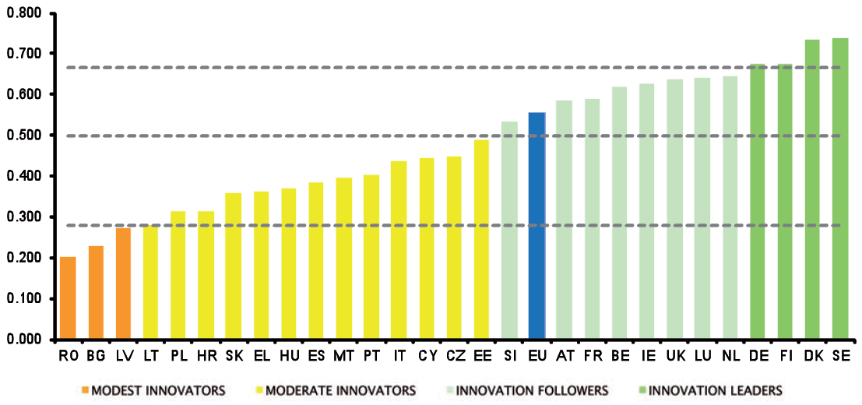

Among Modest and Moderate innovators Hungary shows the best performance concerning the economic effects of the firm investments.

The research and development sector has maintained and even strengthened its scientific standards in some science fields. This is also reflected by the participation data of the 7th Framework Programme: among the new Member States the second highest number of successful applications was submitted from Hungary, after Poland, meaning that Hungary won the second highest amount of funding. However, if the whole European Union is taken as the benchmark, then these results are more modest in proportion to the population and with regard to the success rate of participants.

(See chart below: Participation of EU13 countries in FP7 –Source: MIRRIS, Interim report, Spring 2014)

EU13 PARTICIPATION IN FP7
 | Population in million inhabitants | Number of beneficiaries | Million Euros captured | Success rate beneficiaries | Success rate in Euros | Number of beneficiaries per million inhabitants | Euros per inhabitant | Euros per beneficiary
BG | 7.30 | 585.00 | 83.00 | 16.40 | 10.30 | 80.14 | 11.37 | 141880.34
CY | 0.80 | 357.00 | 63.00 | 15.60 | 10.60 | 446.25 | 78.75 | 176470.59
CZ | 10.50 | 1100.00 | 200.00 | 19.90 | 14.70 | 104.76 | 19.05 | 181818.18
EE | 1.30 | 412.00 | 68.00 | 21.20 | 15.40 | 316.92 | 52.31 | 165048.54
HU | 9.90 | 1260.00 | 220.00 | 20.30 | 14.70 | 127.27 | 22.22 | 174603.17
LT | 3.00 | 350.00 | 48.00 | 20.10 | 14.80 | 116.67 | 16.00 | 137142.86
LV | 2.00 | 249.00 | 30.00 | 21.70 | 11.60 | 124.50 | 15.00 | 120481.93
MT | 0.40 | 153.00 | 14.00 | 19.30 | 10.30 | 382.50 | 35.00 | 91503.27
PL | 38.50 | 1834.00 | 344.00 | 18.50 | 12.10 | 47.64 | 8.94 | 187568.16
RO | 21.30 | 862.00 | 119.00 | 14.60 | 8.50 | 40.47 | 5.59 | 138051.04
SI | 2.00 | 717.00 | 131.00 | 15.90 | 11.40 | 358.50 | 65.50 | 182705.72
SK | 5.40 | 401.00 | 62.00 | 18.30 | 11.80 | 74.26 | 11.48 | 154613.47
EU12 | 102.40 | 8280.00 | 1382.00 | 18.48 | 12.18 | 80.86 | 13.50 | 166908.21
EU27 | 504.70 | 90237.00 | 29291.00 | 21.70 | 19.30 | 178.79 | 58.04 | 324600.77
HR | 4.40 | 317.00 | 59.00 | 17.10 | 10.50 | 72.05 | 13.41 | 186119.87
EU28 | 509.10 | 90554.00 | 29350.00 |  |  | 177.87 | 57.65 | 324116.00

In Horizon 2020 the main condition of successful participation is high-level excellence. A composite indicator is developed to measure the research excellence in Europe, meaning the effects of the European and national policies on the modernization of research institutions, the vitality of the research environment and the quality of research outputs in both basic and applied research. According to the research excellence indicator Hungary has the highest value among the countries of our region.

Policies and Strategies in Science, Technology and Innovation
The Hungarian Government adopted the National Research and Development and Innovation (2013-2020) Strategy (RDI strategy) – Investment in the Future in July 2013.

The RDI strategy sets the goal of renewing and strengthening the innovation system as a whole by strengthening the knowledge bases, knowledge diffusion and knowledge utilization. A policy mix serves the purpose of advancing the objectives of the strategy: the direct instruments (more than 2 billion EUR is dedicated to R&D&I in the Economic Development and Innovation Operative Programme 2014-2020), the indirect instruments (tax allowances in particular for the intramural R&D activity) and the demand-side instruments. The systematic interventions are directed to support the completion of the national innovation system through encouraging inter-sectorial relationships, networking or developing policy management, official acts or services.

The goal of the strategy is expressed by quantified objectives complying with the undertakings of the National Reform Programme submitted to the European Commission in 2011 and elaborated in relation to the Europe 2020 strategy:

Hungary will increase its gross domestic expenditure on R&D to 1.8% by 2020 and to 3% by 2030.

As a complementary objective, the business enterprise expenditure on R&D will rise to 1.2% by 2020.

Additional quantified objectives based on the main components of the strategy complement the overall vision:

During the seven years of the strategy in Hungary, by 2020:

- +30 larger research and technological development groups will join the “world’s elite”;
- +30 R&D research centres of large global companies will be established/strengthened;
- +30 R&D intensive macro-regional medium-sized enterprises will produce and provide services;
- +300 RDI and growth oriented small enterprises (“gazelles”) will find their place in the global market
- +1000 innovative start-ups will get the funding required for starting their activities;
- many innovative supplier companies with national decision making centres will provide services to the multinational companies that have already been established or will be established in Hungary.

(The "+" marking in the objectives listed above indicates the new, additional capacities to be introduced in the national innovation system compared with the current status.)

In order to achieve the objectives of the National Research, Development and innovation Strategy and the National Reform Programme related to the Europe 2020 Strategy, the Government has adopted the National Smart Specialisation Strategy (S3).

The National Smart Specialisation Strategy of Hungary is available here:
http://nkfih.gov.hu/policy-and-strategy

National Mobility Programmes and Initiatives

Momentum – attracting outstanding researchers to Hungary

I) The objective of the Momentum (Lendület) Program focuses on the renewal of the research teams of the Academy and participating universities via attracting outstanding researchers from abroad or keeping them in Hungary. The Momentum program aims to halt the emigration of young researchers, promotes career possibilities, and increases the competitiveness of HAS's (Hungarian Academy of Sciences) research institutes and participating universities.

The mission of the Momentum Program is to support excellence and mobility. The HUF 400 million allocated for new Momentum projects in 2014-2015 allows for approximately 8-12 new Momentum research teams. Momentum financial funding may extend to a maximum of 5 years.

Researchers with a scientific degree are invited to submit applications to head new Momentum research teams in two categories:

1. researcher at the outset of her/his independent research career, who may successfully apply to ERC for research funding in the “Starting” or “Consolidator” categories,
2. researcher with an independent research career in progress, who may successfully apply to ERC for research funding in the “Consolidator”, or Advanced categories.

For more information please visit: http://mta.hu/english

Stipendium Hungaricum – establishing contacts through higher education

II) The Hungarian Government announced the policy of “Global Opening, as part of which the Stipendium Hungaricum Scholarship Programme was launched in 2013 for foreign students

The aim of the programme is to promote cultural understanding, economic and political relations between Hungary and other countries. 736 students from 30 countries study at 20 Hungarian universities in the 2014/15 academic year. The scholarship provides: free visa, no tuition fees, dormitory places or additional contribution to accommodation costs ca. €100, monthly stipend ca. €130 for undergraduate/master students or ca. €320 for PhD students, medical insurance.

For more information please visit: http://www.stipendiumhungaricum.hu

- Joint Activities with China in 2015

Hungary currently maintains bilateral science and technology (S&T) cooperation with
46 countries including China. The Agreement on Cooperation in Science and Technology between Hungary and the People's Republic of China was ratified in 2002. The National Research, Development and Innovation Office is in charge of coordinating the joint activities. During the 6th meeting of the Hungarian-Chinese Science and Technology Joint Committee 36 projects were proved to be eligible for financial support. The 7th meeting of the Joint Committee will be held in the near future in Budapest.

A delegation responsible for research, development and innovation from the Government of Chongqing (China) had negotiations with Hungarian counterparts (National Research, Development and Innovation Office, the Ministry of Foreign Affairs and Trade, Bay Zoltan Nonprofit Ltd. for Applied Research, Hungarian National Trading House) on 10th of September 2015 in Budapest. Between the Bay Zoltan Non-profit Ltd. for Applied Research and the Chongqing Hi-Tech Incubation Centre a cooperation agreement was signed, moreover the Chinese delegation recommended the establishment of a Chinese-Hungarian Centre of Technology Transfer in Chongqing.

- Examples for cooperation between Hungarian Academy of Sciences (HAS) and Chinese Academy of Sciences (CAS) and its research institutes:

- The HAS and the CAS has a bilateral agreement in order to promote the participation in joint research programmes, and in exchange programmes for researchers.

- The Wigner Research Center for Physics and the Institute of Modern Physics in Lanzhou has signed an agreement on establishing a joint research laboratory and providing joint research activities between 2016 and 2018.

- A Chinese-Hungarian Joint Laboratory for Ecological Research of Danube and Pearl rivers is in the preparation phase by the Centre for Ecological Research of the HAS and the South China University of Technology.

- A future cooperation is expected between the Hohhot Branch of Chinese Academy of Agricultural Mechanization Sciences and the National Agricultural Research and Innovation Centre of Hungary (NARIC).

Mahesh Kumar Singh, chief advisor of the Hungarian NARIC was invited in March 2015 to Hohhot in order to negotiate about a new bilateral institutional cooperation regarding animal feeding. The Chinese delegation from Hohhot is expected to arrive to NARIC (Gödöllő) in late 2015.

- Examples for cooperation between universities:

- By the Eszterházy Károly University of Applied Sciences (Eger) and the Beijing Union University a mobility agreement (eligible for higher education students and also for lecturers) was signed in 2013. In 2015 a Chinese delegation of 20 students arrived to Eger in order to participate at a summer training programme of the Hungarian University. The Parties are planning to provide a 3-year university degree programme for the students arriving from the other country.

- A delegation from the Faculty of Healthcare of University of Miskolc (Hungary) in 2014 visited the Beijing Sport University in order to establish institutional relations and to propagate its specialised physiotherapist degree program.

- The National University of Public Administration (Budapest) has strong institutional relations with Chinese universities thanks to its Chinese Public Administration, Economy and Social Sciences Research Center, such as: Chinese Academy of Government, University of Minzu. The cooperation covers mobility and scholarship programs.

- The Faculty of Science of Eötvös Loránd University (Budapest) and the
China University of Geosciences (Wuhan) in 2006 signed a cooperation agreement on establishment of the Chinese-Hungarian Joint Laboratory of Environmental Sciences and Health.

Joint Committee meeting Target participants - representatives of implementing ministries, universities and academies of sciences

* List of Programmes of Activities with China in 2015 Please fill out the table below.
Programme Title | Contents
Activity A | - Activity (Programme) Outline: Date/Venue/etc.  - Major topic or agenda  - Target Participants  - Relevant Information:
Activity B

- Others

[Description] If you have additional information to deliver, please describe it in detail.

[Description] In order to promote major MS organisations (Universities, Research Organisations, SMEs, etc.) to China, please fill out several major organisations as below:

* Key Research Organisations and Companies Please fill out the table below.

Organisation Name | Detailed information
Organisation 1  (website) | - Organisation type: University/Research Organisations/SME/( )  - Major Research Area/Product:  - Major Activities with China:  - Future Plans:  - Contact Information:  - Others:
Organisation 2
* The organisations/companies should be present in China or having active cooperation programmes with China.

