SERBIA  Country Outline  - GDP: 43.87 billion US dollars / - GDP Per capita: 4245.54 US dollars  - Areas of marked S&T specialisations: /  Contact Information  - Name / Position: (Mr/Ms/Dr/Prof) MS Marina Vukobratovic Karan / senior adviser , head of the Group of National Innovation System Phone no. / e-mail: (+381) (0)113616526/ marina.vukobratovic @mpn.gov.rs / / | National Flag  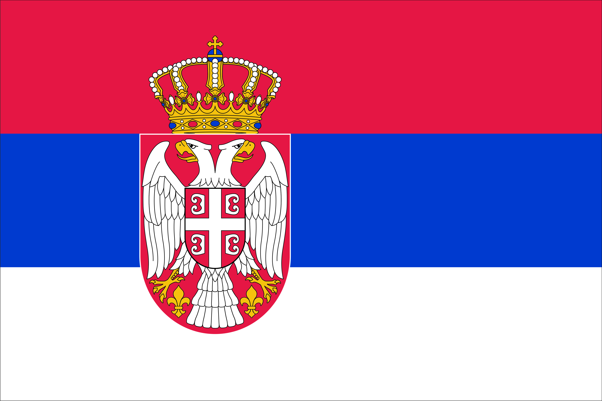

Introduction: Please provide a short introduction paragraph of your country by focusing on Science, Technology and Innovation.

1. Policies and Strategies in Science, Technology and Innovation
[Description] Please describe your STI Policies and strategies in detail. If needed, please provide some statistics (table, figures, etc.)
The framework of policy is formulated through:
Strategies:
- The Strategy of Scientific and Technological Development of the Republic of Serbia 2010-2015
Activities relevant for implementation of the Strategy:
- Establishing institutional and legal framework for Strategy implementation;
- Improved legislations in the field of scientific research and innovation activities and the protection of intellectual property;
- Research activities carried out in 7 priority areas;
- Advancement of scientific research through partnership between scientific community and relevant domestic and international institutions;
- Support technological development, technology transfer and national innovation activities;
- International scientific and technological cooperation;
- Increase of the funding invested in research and development diversification of the funding and investment in infrastructure.
Legislative acts:
The Law on Scientific and Research Activity
- Defines the basis by which scientific and research activity in Serbia is financed in accordance with the State budget;
- Encourages R&D activity in Serbia;
- Provided a stronger cooperation between the Institutes and Faculties;
- Partnership with Industry;
- Cooperation with Serbian Diaspora through joint projects;
- Partnership and cooperation with international organizations on joint programs and projects;
- Partnership with other ministries in the implementation of capital projects of strategic national importance;
-Defines intellectual property rights;
- Allocates budget resources to R&D organizations for the programs defined by the Law and monitors the implementation.

The Law on Innovation Activity
- The legal framework for the formation of the national innovation system in Serbia is established through this Law;
- The law regulates framework for formation of organizations for support of innovation activities and technology transfer centers;
-Register of innovation organizations;
- Support for Societies of Inventors and individuals/innovators;
- Fostering cooperation with institutions on local and regional level in the field on innovation and technology transfer, e.g. regional chamber of commerce, regional secretariat for science and technological development, Intellectual Property Office RS;
- Defines intellectual property rights;
The Innovation Fund was established by this Law.
Competences in the field of innovation activity:
- Responsible for establishing and implementing innovation policy
- Stimulating techno-entrepreneurship
- Transposition of knowledge and technologies into the economy
- Development and upgrading the innovation system
- Regulations in the area of protection and transposition of IPR
- Providing conditions and monitoring implementation of the Programmes of Innovation Activity
- Submitting proposals to the Government regarding the measures for eliminating detected problems (if needed)

2. National Programmes and Initiatives
[Description]
Ministry of Education, Science and Technological Development (MoESTD) contracts and supports projects of scientific and technological cooperation between our and foreign scientific and research organizations (SRO) on the basis of international bilateral agreements including bilateral projects with China. Also, ministry participate in programmes: JRC, NATO SPS, COST, EUREKA,FP7,HORIZON2020
Multilateral cooperation: CEI (Central European - initiative), BSEC (Organization of the Black Sea Economic Cooperation)
* List of National Programmes open to the world Please fill out the table below.
Programme Title | Contents
Programme A  (website) | - Cooperation Type: Joint Research  - Funding Organisation: Ministry of Education Science and Technological Development  - Call Opening/Closing Date:  - Participation Qualification: scientific staff  - Project Duration: 2 years  - Funding Scale and Funding Scheme:  - Research Fields: Information and communication technology,Biomedecine and human health, New materials and Nano Science, Agriculture and food, Biotechnology, Energy and Energy efficient, Environment protection and countering climate change  - Matching fund from Chinese government (if yes, what is funding process?)  - Others:
Programme B

3. Joint Activities with China in 2015
[Description] If you have joint programmes or event at the public level and private level, please describe it in detail.
Starting from the need to support scientific and technological cooperation on the basis of parity and mutual interest, in compliance with national priorities in the field of science and technology in both countries agreed and signed the Protocol to the Second Session of the Mixed Serbian-Chinese committee on 25.June 2013.
The Joint Committee has found that the public call for co-financing of joint research projects between the Republic of Serbia and the People's Republic of China were reported 29 projects, selected 15 projects in 2013/2014, project duration 2 years, 1st July 2013- 1st July 2015.
Next Public call launched on third quarter 2014 for co-financing scientific and technological cooperation between the Republic of Serbia and the People's Republic of China for the period 2015-2016 .
Joint Committee meeting
The second session of the Serbia- China Joint Committe was held on the basis of the Agreement on Scientific and Technological Cooperation between the Republic of Serbia and the People's Republic of China.
* List of Programmes of Activities with China in 2015 Please fill out the table below.
Programme Title | Contents
Activity A | - Cooperation between the Ministry of Education Science and Technological Development of the Republic of Serbia and the Ministry of Education of the People΄s Republic of China through the public calls for for co-financing scientific and technological cooperation.  The subject of the competition is co-financing the mutual visits of researchers (the cost of travel and accommodation) to be implemented within the project activities of bilateral scientific and technological cooperation. The competition is reported to researchers and teams of researchers who are employed in scientific research organizations that are eligible in accordance with the Law on Scientific Research.Preference is given to proposals of bilateral projects which are based on scientific research projects funded by the Ministry of Science and Technological Development of Republic of Serbia, which are in line with the Strategy of Scientific and Technological Development of Republic of Serbia from 2010 to 2015, or which are funded by international source (eg. the Horizon 2020 program and other international and regional organizations) and project developers have not participated in the previous project cycles with the People's Republic of China.
Activity B
4. Others
[Description] If you have additional information to deliver, please describe it in detail.

[Description] In order to promote major MS organisations (Universities, Research Organisations, SMEs, etc.) to China, please fill out several major organisations as below:

* Key Research Organisations and Companies Please fill out the table below.
Organisation Name | Detailed information
Organisation 1  (website) | Organisation type: University of Belgrade ( Faculty of Agriculture, Faculty of Mechanics, Faculty of Electrical Engineering,Faculty of Technology and Metalurgy, Faculty of Chemistry)  Contact Information: www.bg.ac.rs ; kabinet @rect.bg.ac.rs  Center for Transfer Technology, University of Belgrade  Contact information : www.ctt.bg.ac.rs; ctt@rect.bg.ac.rs  Organisation type: University of Novi Sad ( Faculty of Agriculture, Faculty of Technical Science)  Contact Information : ) www.uns.ac.rs; kabinet @rect.uns.ac.rs  Organisation type: University of Niš ( Faculty of Mechanics)  Contact Information : www.ni.ac.rs; kabinet@rect.ni.ac.rs  Organisation type : Institute of Nuclear Science”Vinča”,Belgrade  Contact Information :www.vin.bg.ac.rs ; office @vin.bg.ac.rs  Organisation type : Institute “Mihajlo Pupin”,Belgrade  Contact Information : www.imp.bg.ac.rs; info@pupin.com  Organisation type : Institute for Vegetable and vegetable crops, Novi Sad  Contact Information :www.nsseme.com; institut@ifvcns.ns.ac.rs  Organisation type : Institute”RT-RK”, Novi Sad (Institute for Computer Based Systems)  Contact Information : www.rt-rk.com; info@rt-rk.com
Organisation 2
* The organisations/companies should be present in China or having active cooperation programmes with China.

